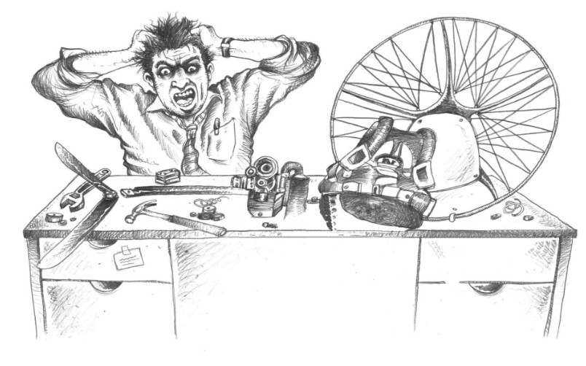

Spark plugs: how they work, the BR9ES code and heat range
Technical note for instructors and pilots · Version 1.0 · 30 October 2026
Paramotor SA (Pty) Ltd t/a Apex Adventures · SACAA DTO 0012

Technical notes · General

Scope. How a spark plug works, how to read an NGK code such as BR9ES and BR8ES, why the plug has an R, what heat range means and how to choose between a BR8ES and a BR9ES on a paramotor two-stroke. The code and heat range explanations are from NGK and plug suppliers. The Vittorazi fitment is from one reseller. The plug and gap in your engine's own manual always win. Check each Apex engine's manual and fill in the table in section 8.

1. How a spark plug works
A spark plug is a gap in a sealed, insulated tube. The ignition (the magneto and CDI on our engines) sends a very high voltage pulse down the lead. The voltage climbs until it jumps the gap between the centre electrode and the ground electrode. The spark lights the compressed fuel and air in the cylinder.
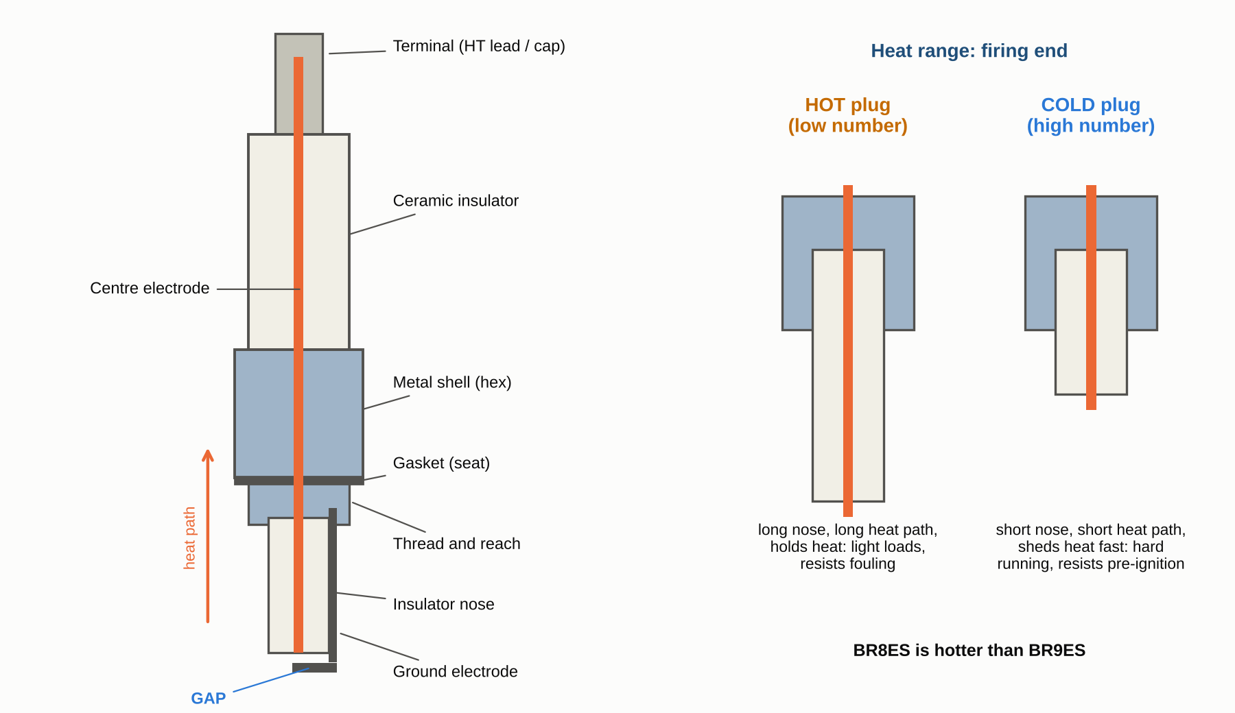
Spark plug parts (left) and the difference between a hot and a cold plug (right). Schematic only, not to scale. Apex drawing.
Part | What it does
Terminal | Where the lead or plug cap connects. A solid terminal is preferred. A plug with a loose, removable terminal nut can lose contact inside the cap and stop the spark (redo-parts, on the NGK 3961 against the 5422)
Ceramic insulator | Keeps the high voltage inside the plug and carries heat away from the tip
Centre electrode | Carries the voltage to the tip. Many have a copper core to conduct heat
Metal shell and thread | Screws into the head, seals the plug and carries heat from the tip into the cylinder head
Gasket (seat) | Seals the combustion gases and makes the heat path into the head
Ground electrode (strap) | The other side of the gap. Welded to the shell
Gap | The distance the spark jumps. Set with a wire gauge

The plug also has a second job: it is a heat exchanger. The tip must be hot enough to burn off deposits and cold enough not to glow and light the mixture early. That balance is the heat range (section 4).

2. Reading the code: BR9ES and BR8ES
NGK codes read left to right, each letter or number being one feature.
Code | BR9ES | BR8ES | Meaning
B | B | B | 14 mm thread diameter (M14 × 1.25), with a 20.8 to 21 mm hex (13/16 inch)
R | R | R | Resistor plug (see section 3)
Number | 9 | 8 | Heat range. Higher number is colder. 8 is hotter than 9
E | E | E | 19 mm thread reach
S | S | S | Standard centre electrode (copper core)

Other facts from the suppliers' data sheets:
- Factory gap 0.8 mm (0.031 to 0.032 inch) for both the BR9ES and the BR8ES.
- A suffix after a dash (for example BR8ES-9) is the pre-set gap code. NGK's code table gives 9 as 0.9 mm (.036 inch).
- The R plug carries a 5 kΩ resistor (BR9ES data sheet).
- Same plug, different terminal: some stock numbers have a removable nut, others a solid terminal. Buy the solid terminal.
- Heat numbers run from about 2 (hot) to 11 or higher (cold) on NGK's scale. The two plugs you use differ by one step.
Other plug types use extra letters, for example G (fine-wire), IX (iridium) and VX (platinum). They are for other engines. Do not fit one in a paramotor engine unless the engine maker lists it. A plug of the same thread and reach but a different heat number or electrode is not a like-for-like swap.

3. Why is there an R?
The R is a built-in resistor in the plug, between the terminal and the centre electrode. It suppresses the electrical noise that the spark makes.
- Every spark is a small radio transmitter. NGK says resistor plugs "suppress ignition noise generated during sparking". The noise is called electromagnetic interference (EMI) or radio frequency interference (RFI).
- What it can upset: NGK lists sound systems, cell phones, two-way radios and engine management systems. It adds that EMI/RFI can cause premature failure of other electronic components.
- For us: many pilots fly with a helmet radio, GPS, vario and instruments next to the engine, and some engines have electronic ignition or fuel systems. An R plug keeps the noise out of the radio and out of the electronics. That use is our reading of NGK's statement. NGK's page does not name paramotors.
- No R, no protection. A plug without the R (for example a plain BP9ES) has the same thread and heat range but gives no suppression. Do not swap it in because it is cheaper or easier to find.
- NGK's page gives no figure for the spark power lost to the resistor. The data sheet gives the resistance as 5 kΩ.

4. Heat range: hot and cold plugs
Hot and cold describe how fast the plug passes heat to the head. They do not describe the temperature of the spark (MXA).
- Hot plug (low number): long thin insulator nose, long heat path. It holds heat. It suits low-power, light-duty running and burns off deposits.
- Cold plug (high number): short thick nose, short heat path. It sheds heat quickly. It suits hard running.
- Heat flows from the electrode and insulator nose into the shell, then into the head. The nose shape is the main sign: a long thin nose runs hot, a short thick one runs cold.
Wrong heat range, from NGK:
Problem | What happens
Too cold (number too high) | The tip stays too cool. Deposits build up on the firing end and make a leak path, so sparks are lost
Too hot (number too low) | The plug overheats. Pre-ignition, melted electrodes, piston seizure and erosion

On a paramotor the engine is under high load for the whole flight, and a seizure at 300 ft is not a small problem. So the heat range is chosen by the engine maker, and it is not a thing to change for fun.

5. BR8ES or BR9ES: choosing between them
- Vittorazi: the Vittorazi plug (part M020) is the NGK BR9ES, listed by Aviator PPG for the Atom 80, Moster 185 and Cosmos 300. That is one reseller's listing. Check the manual for your engine.
- BR8ES is one step hotter than the BR9ES. You said some makers specify it. Neither plug is "better": each is right for the engine it was chosen for.
- The rule is simple: fit what the engine manual says.
If a pilot asks about changing one step, use this decision guide. It is general workshop practice and not from an engine maker.
Symptom (after the engine is correctly jetted and oiled) | Possible direction | Do first
Plug fouls, wet or sooty, hard starting, rough at idle | Plug running too cold (hotter plug may help) | Check the mixture, oil ratio, idle setting, choke and the plug itself
White or blistered insulator, melted electrode, pre-ignition signs, hot cylinder head temperature (CHT) or exhaust gas temperature (EGT) | Plug or engine running too hot (colder plug may help, but the cause comes first) | Ground the engine. Check for a lean mixture, air leaks, the wrong fuel or oil, cooling and timing

Do not change heat range as a fix. A hotter or colder plug hides the problem and does not remove it. A lean mixture, an air leak or poor cooling will still damage the engine. A change from the manual's plug needs the CFI's approval and, where possible, the engine maker's. Remember that on a hot, high day the engine already runs leaner and hotter (see the Density Altitude note), so check the plug colour after every change in field, season or temperature.

6. Gap, fitting and care
- Engine cold. Never take a plug out of a hot head. Aluminium threads strip easily.
- Clean the seat and the hole. Blow out loose dirt so it does not fall into the cylinder.
- Check the gap with a wire gauge and set it to the manual's figure (factory 0.8 mm). Open or close the gap by bending the ground electrode only. Never press or bend the centre electrode or the insulator.
- Start the plug by hand. If it does not turn freely, stop. It is cross-threaded.
- Tighten to the engine manual's torque. Over-tightening damages the thread and the plug. Under-tightening leaks heat and gases.
- Push the cap on until it clicks and check that the lead is not near the exhaust or the moving parts.
- Inspect the ground strap. MXA reports a factory dropping the standard BR9ES on one two-stroke because of "issues with the electrode strap breaking off". A strap that breaks off in the cylinder can ruin the engine. Replace any plug with a cracked, loose or badly eroded strap.
- Replace on a schedule. Aviator PPG recommends a new plug about every 20 hours and says hard starting, rough running after tuning, or "caked brown" at the tip are signs it is due. That is a reseller's advice. Use the engine manual's interval once it is confirmed.
- Carry a spare of the same type, a plug spanner and a gap gauge.

Reading the plug (general guide)
Look at the insulator tip after a normal flight at power, not after idling. This table is general workshop practice and is not from one engine manual.
Tip colour | Usually means
Light tan to grey-brown | Healthy mixture and the right heat range
Black, dry and sooty | Rich, or a plug running too cold
Black, wet and oily | Too much oil, or a rich mix, or poor combustion
White, chalky or blistered | Lean or too hot. Stop and investigate before flying again
Melted electrode or shiny beads | Overheating or pre-ignition. Ground the engine
Caked brown (reseller's sign) | Plug is due for replacement

7. Quick answers
- Why BR9ES? It is what the engine maker chose: 14 mm thread, resistor, a heat range for the load, 19 mm reach, standard electrode.
- Why BR8ES? One step hotter. Some makers choose it for their engine.
- Why the R? To stop ignition noise upsetting radios and electronics.
- Can I use a plug with a different letter? Not unless the manual lists it. Thread, reach and heat range must all match.

8. Apex engine plug list
Fill in from each engine's manual. Row 1 is from a reseller and is to be confirmed.
Engine | Plug in manual | Gap (mm) | Torque (Nm) | Change interval | Source
Vittorazi Moster 185 | NGK BR9ES (Vittorazi M020) |  |  | 20 h (reseller) | Aviator PPG listing. Confirm in the MY25 manual

Plug change record
Date | Engine | Plug fitted | Gap | Hours | Done by | CFI check

9. Sources and cautions
- Spark plugs: heat range (NGK Spark Plugs Australia, ngk.com.au). Heat range 2 to 11, how heat flows, too hot and too cold.
- Resistor spark plugs (NGK Spark Plugs Australia, ngk.com.au). Purpose of the resistor, EMI and RFI, risk to electronics.
- NGK spark plug codes (compiled list, math.uwaterloo.ca) and What do the symbols on an NGK spark plug mean (wemoto.fr). B, R, heat number, E, S, gap codes.
- NGK BR9ES 5722 (zweiradteile.net) and NGK BR8ES-S decoder (redo-parts.com). M14 × 1.25 thread, 19 mm reach, hex size, 0.8 mm gap, 5 kΩ resistor, solid against nut terminal.
- Vittorazi BR9ES spark plug (Aviator PPG, aviatorppg.com). Atom 80, Moster 185, Cosmos 300, 20 hour replacement advice.
- Ask the MXperts: what's hotter, an NGK BR9ES or what? (Motocross Action). Hot and cold mean heat transfer, not spark temperature. Electrode strap issue.

